Characters:

Tank:

So large that the wings appear small. Tank character is not as agile as he is very large and wings are not as effective compared to other characters, this will be translated in game. Also, character makes up for this by being able to absorb a lot of damage.

Smile on face as the character likes to fight.

Very large and stoic character. Has short legs and large frame.

Scars from previous battles.

Healer:

Smile on face as they are a character that is happy to help in any way possible.

Noticeably smaller than other characters, helps character be quicker than other cupids.

No 6 pack as they focus more on healing not fighting

Long range :

Tall and slender

Scar over eye to show battle experience

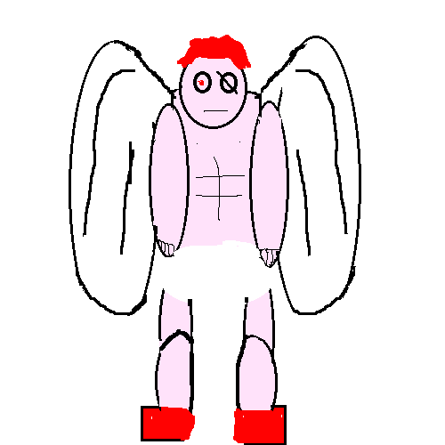

Tends to not smile as much as other characters

Wears shoes because they are stealthy to hide in clouds. Easier for them (character preference) to use long range weapons whilst stationary than flying around.

Main character (balance)

Striking wings to show cupid is not an ordinary cupid. (Different wings to others)

Shoes like long range character to show balance between all characters again.

Thumbs up to show confidence in themselves.

Veins popping from arms

Yellow hair as that is the colour that the traditional cupids have.

Muscular, shows they are strong.

Medium size compared to other characters to show they have a mixture of different features from other classes.

All the characters were given different hair to help them stand out from each other to enforce individualism. Also, they were given body shapes to help them suit their roles more. I did all of this to help mix their personality and in game class work hand in hand.

Inspirations:

Animated show Star Wars bad batch:

<https://www.theguardian.com/tv-and-radio/2021/may/04/star-wars-the-bad-batch-review-badass-clones-strike-back>

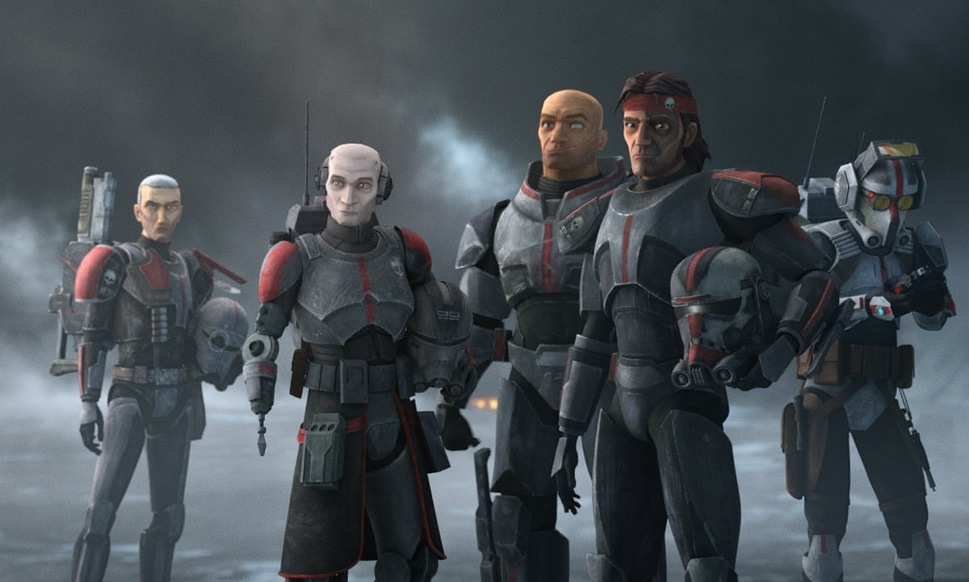  
Power rangers:

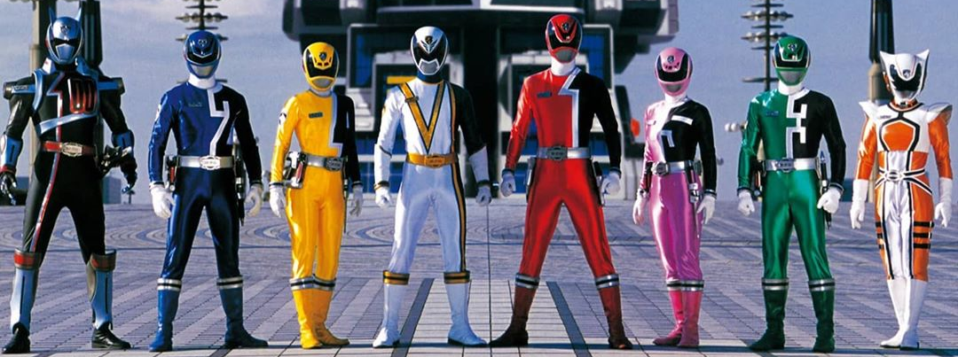

<https://www.google.com/search?q=power+rangers+spd&tbm=isch&ved=2ahUKEwiS6LvVneX0AhWQwYUKHduiDJkQ2-cCegQIABAA&oq=power+rangers+spd&gs_lcp=CgNpbWcQAzIICAAQgAQQsQMyBQgAEIAEMgUIABCABDIFCAAQgAQyBQgAEIAEMgUIABCABDIFCAAQgAQyBQgAEIAEMgUIABCABDIFCAAQgAQ6BwgjEO8DECc6BAgAEENQjhBYvBJgthNoAHAAeACAAWuIAdsCkgEDMy4xmAEAoAEBqgELZ3dzLXdpei1pbWfAAQE&sclient=img&ei=b5K5YdL0IpCDlwTbxbLICQ&bih=865&biw=1707#imgrc=yd5IPL3Dr2WSRM>

Astrix and obelix:

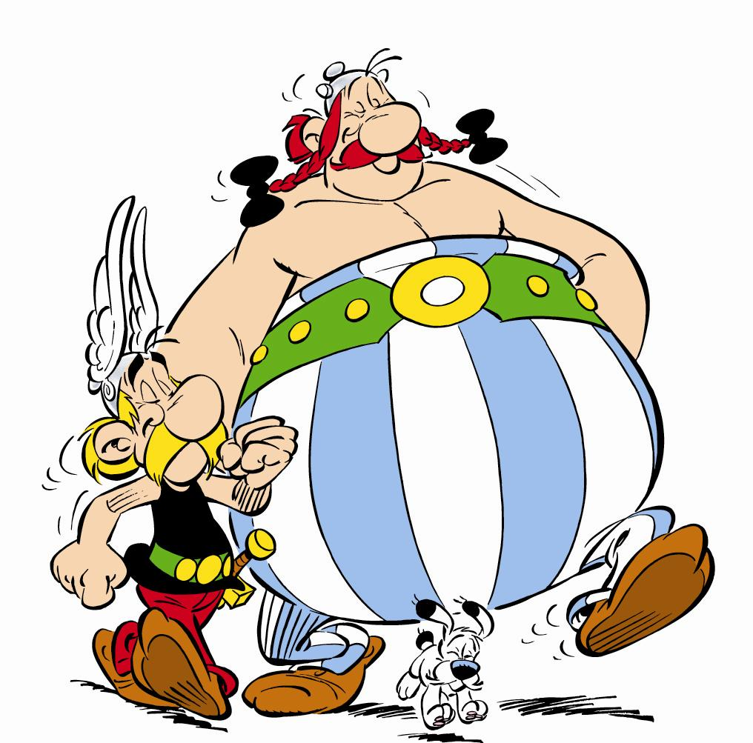

<https://asterix.fandom.com/wiki/Asterix>